**PROJECT REPORT**

**On**

**CMS Project**

**Informaition Technology**

**Submitted to**

**Mr. Uday pratap singh HOD(I.T.)**

**CSJM Govt. Polytechnic Ambedkar nagar**

**Submitted By**

**Mohd Kamleen E182207356000128**





Outline

* Introduction
* Features
* Work Out
* Tools and Languages
* ER Diagram
* DB Design
* Site Tree
* Conclusion





Introduction

* A blog is basically a web site which is used for chronological

listing of blog posts.

* A blog has the most recent content shown first followed by the previously updated content.
* In a blog there are multiple categories and posts written by a large number of authors

3





Features

* The system we have developed allows users to create their

own blog, where users can publish their own opinions.

* In this system there are admins who takes care of the Blog.
* If anyone wants to post first they will have to create a new blog as well as a site account.
* The posts may verified by the admins.
* There has category list where posts can be saved by relevant

category.

* People can like, comment and share the posts





Features (Cont.)

* Full responsive, Compatible with pc, tab and mobile devices
* Like, Comment featured
* Has pagination feature





Tools and Languages

## Tools

1. VScode

2. XAMPP

## Languages

1. SQL

2. PHP

1. HTML
2. CSS
3. Java script

# ER Diagram

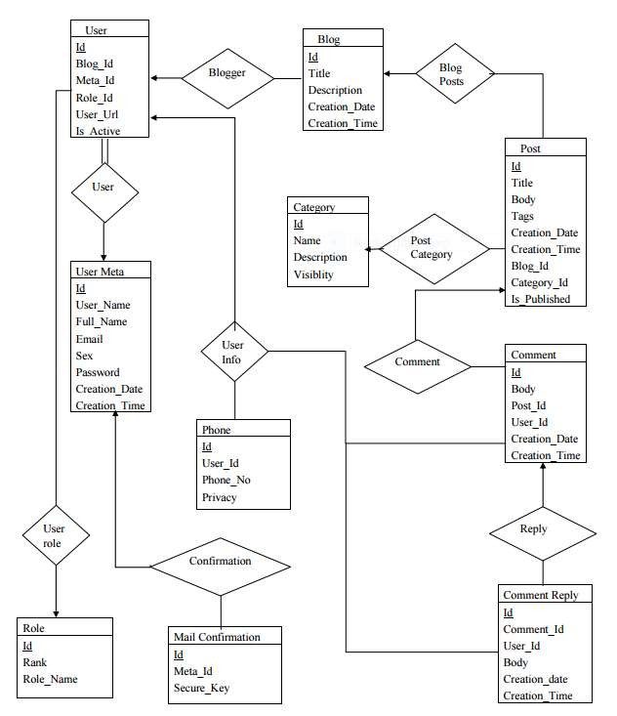

Database Design

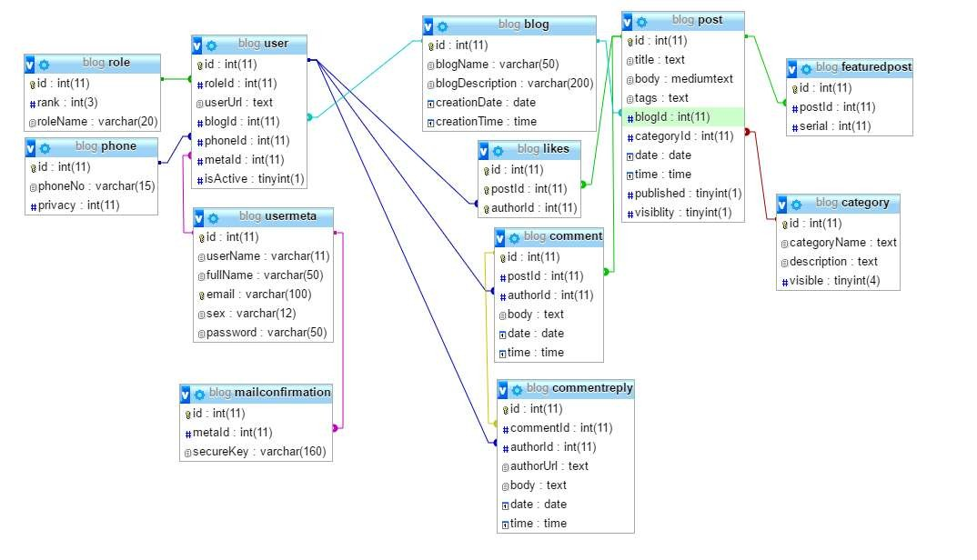

8

# Site Tree



Home

User Admin

Registration

Post



Index

Statistics

Login

Comments

Category

Users

Featured Post

Search

Category



Registered users Only

Notice



Profile

9





Work out

* Let's take a tour in our blog

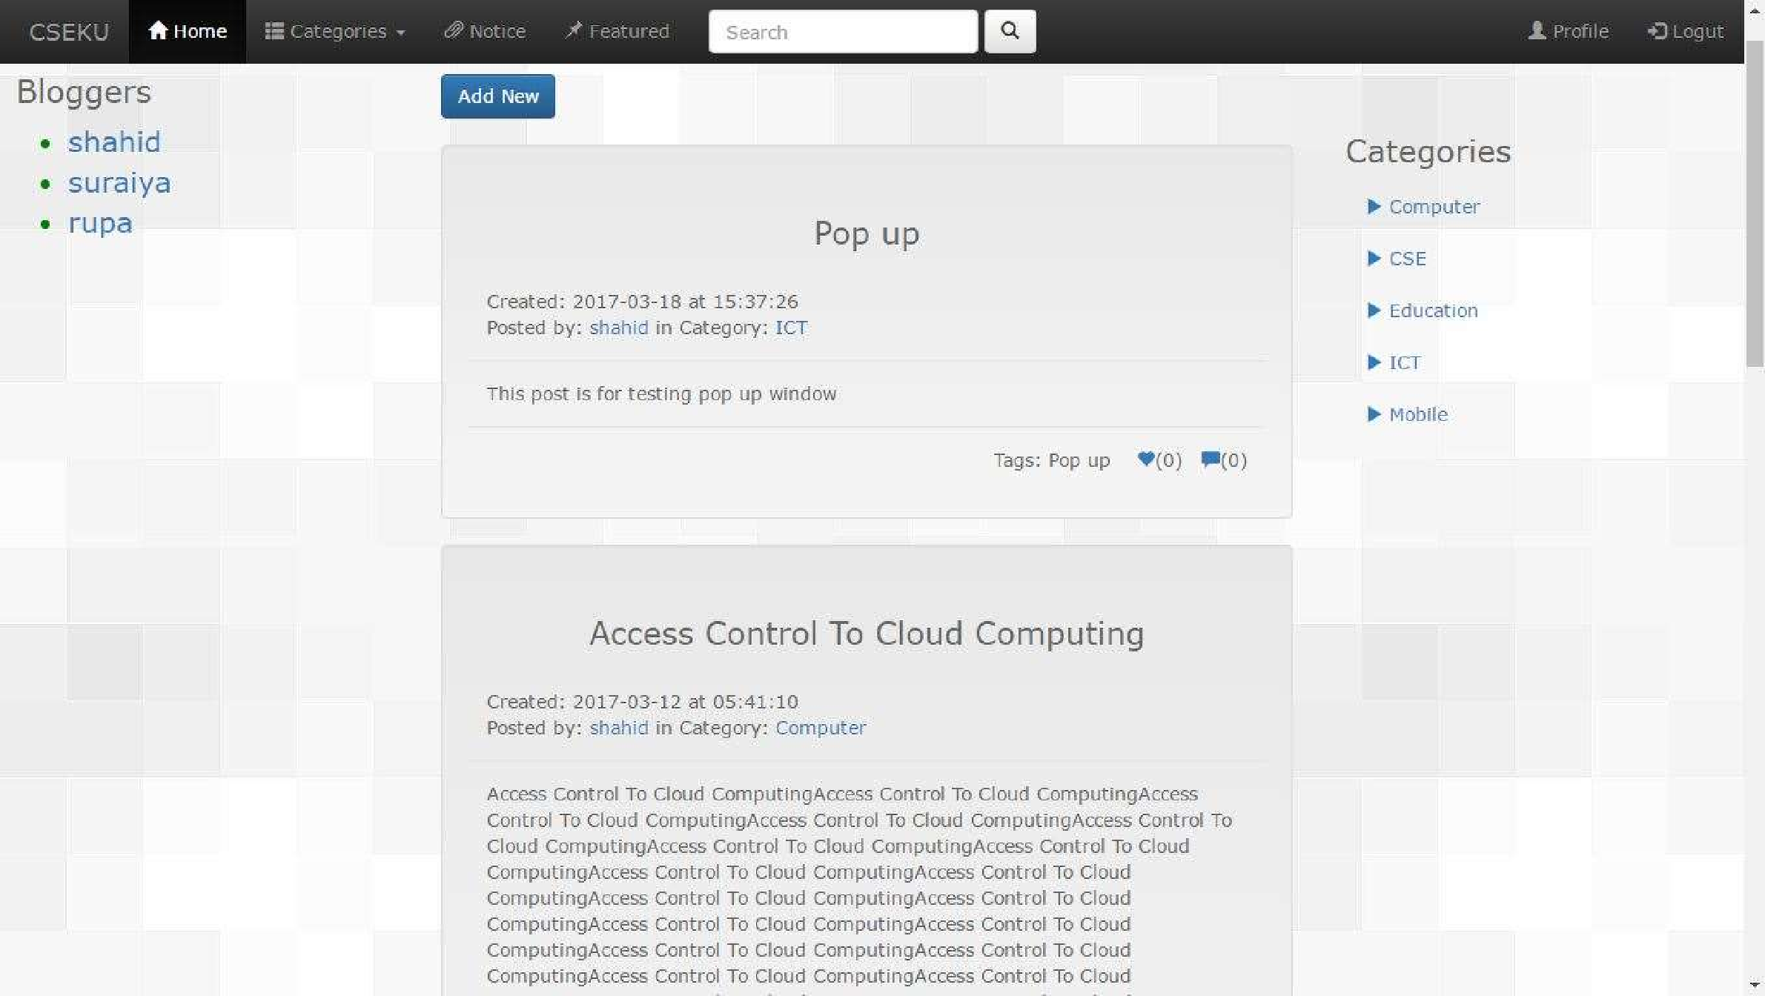

11

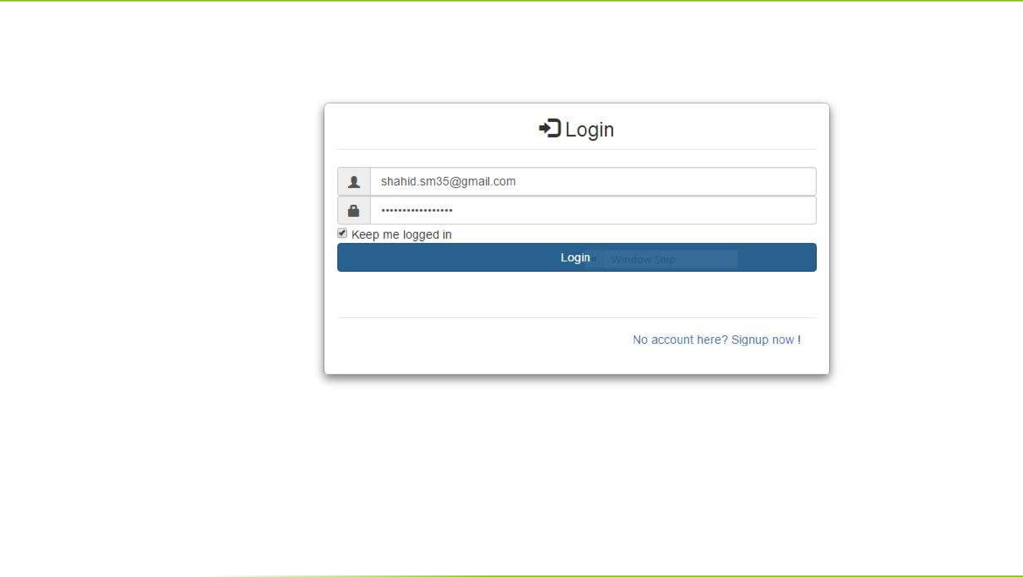

12

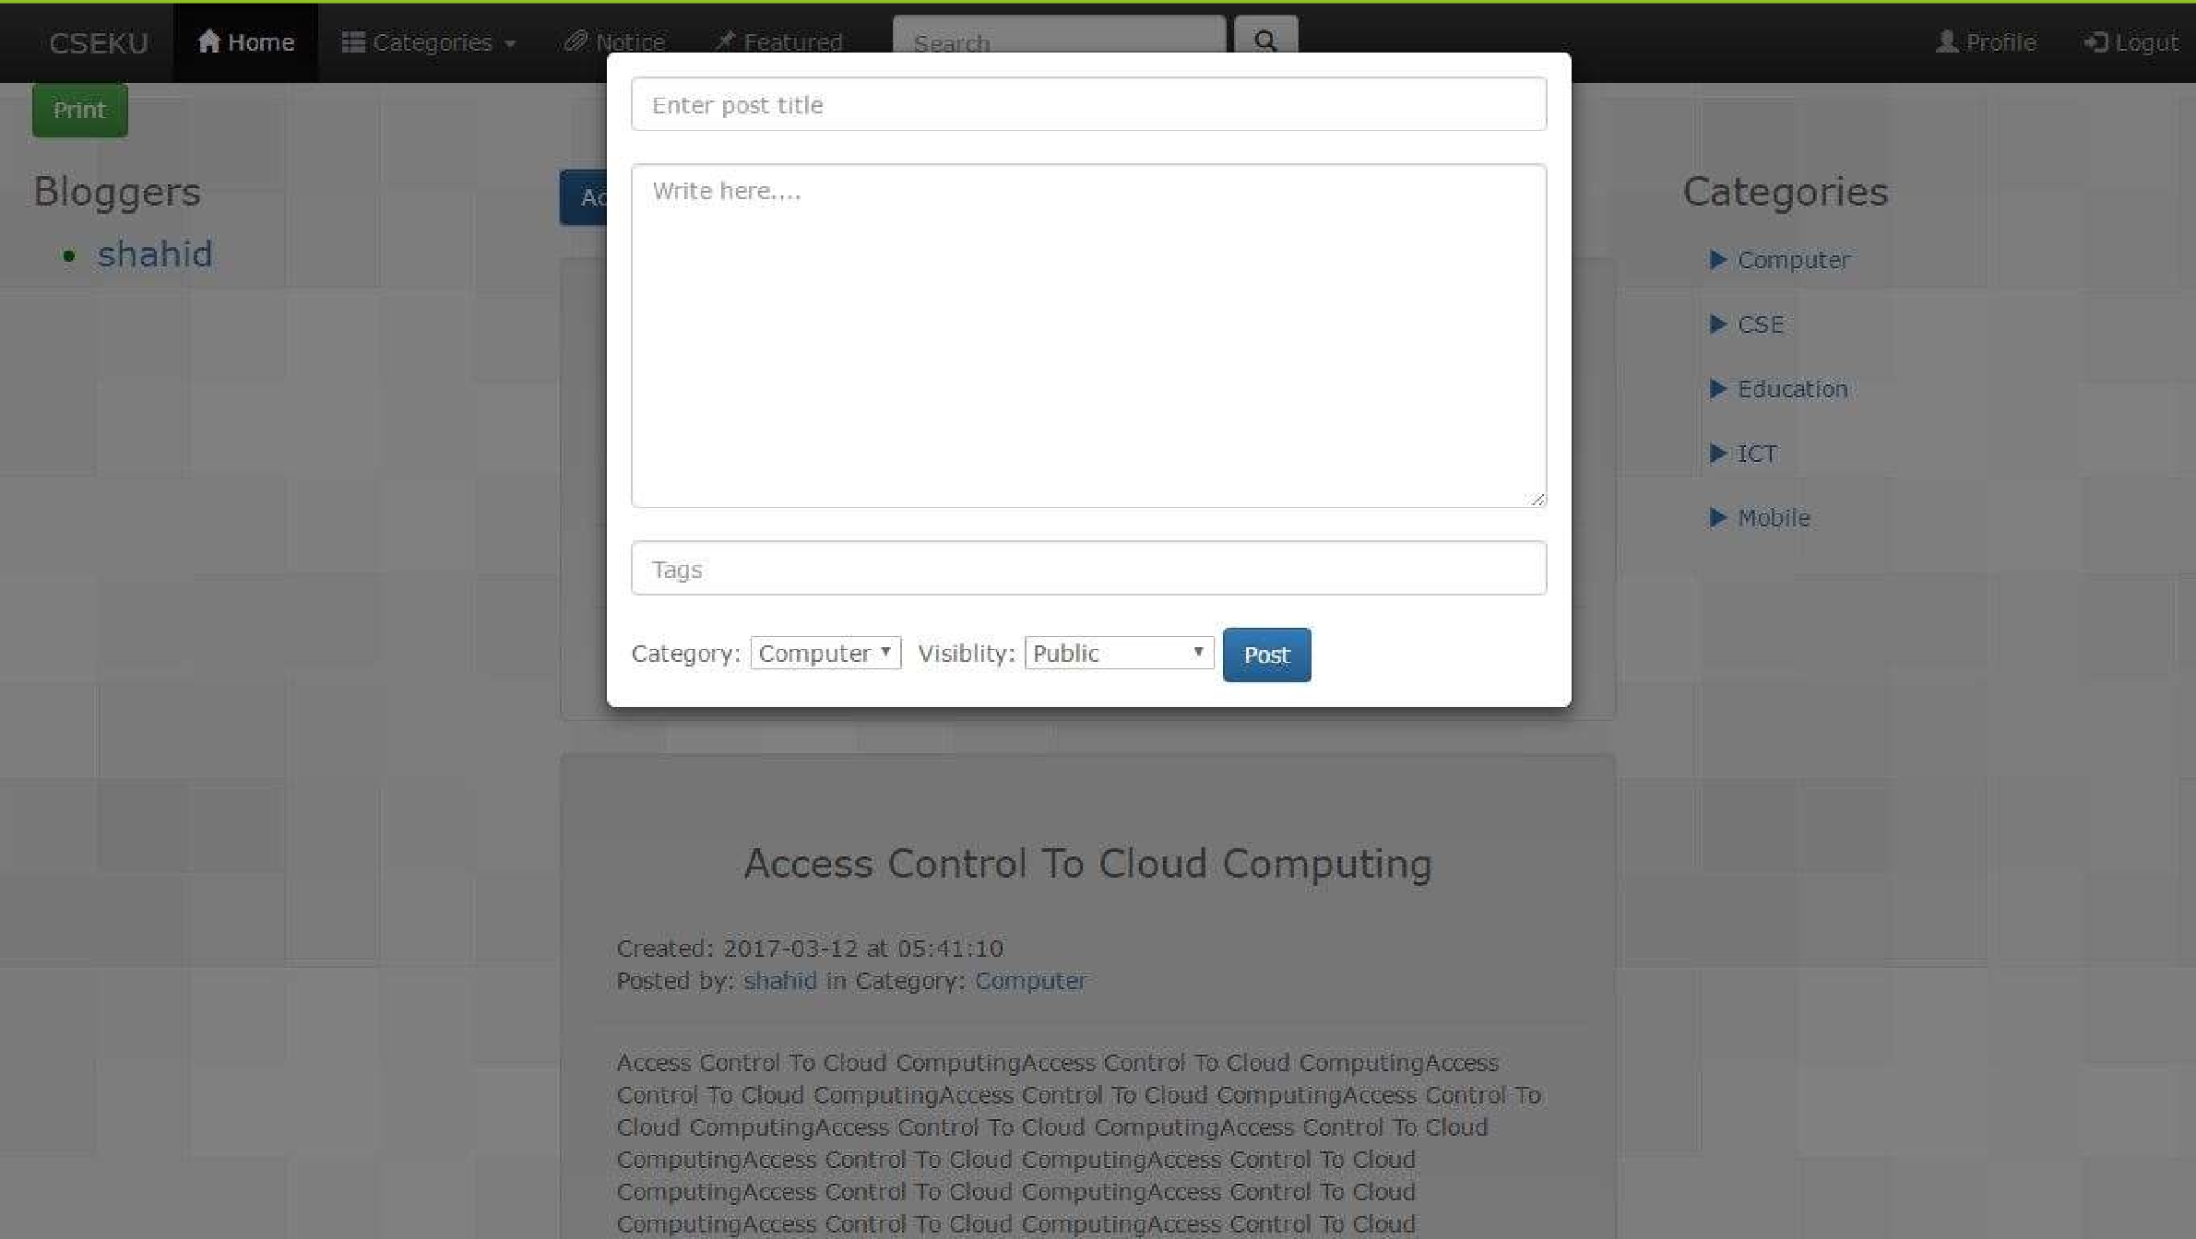

13

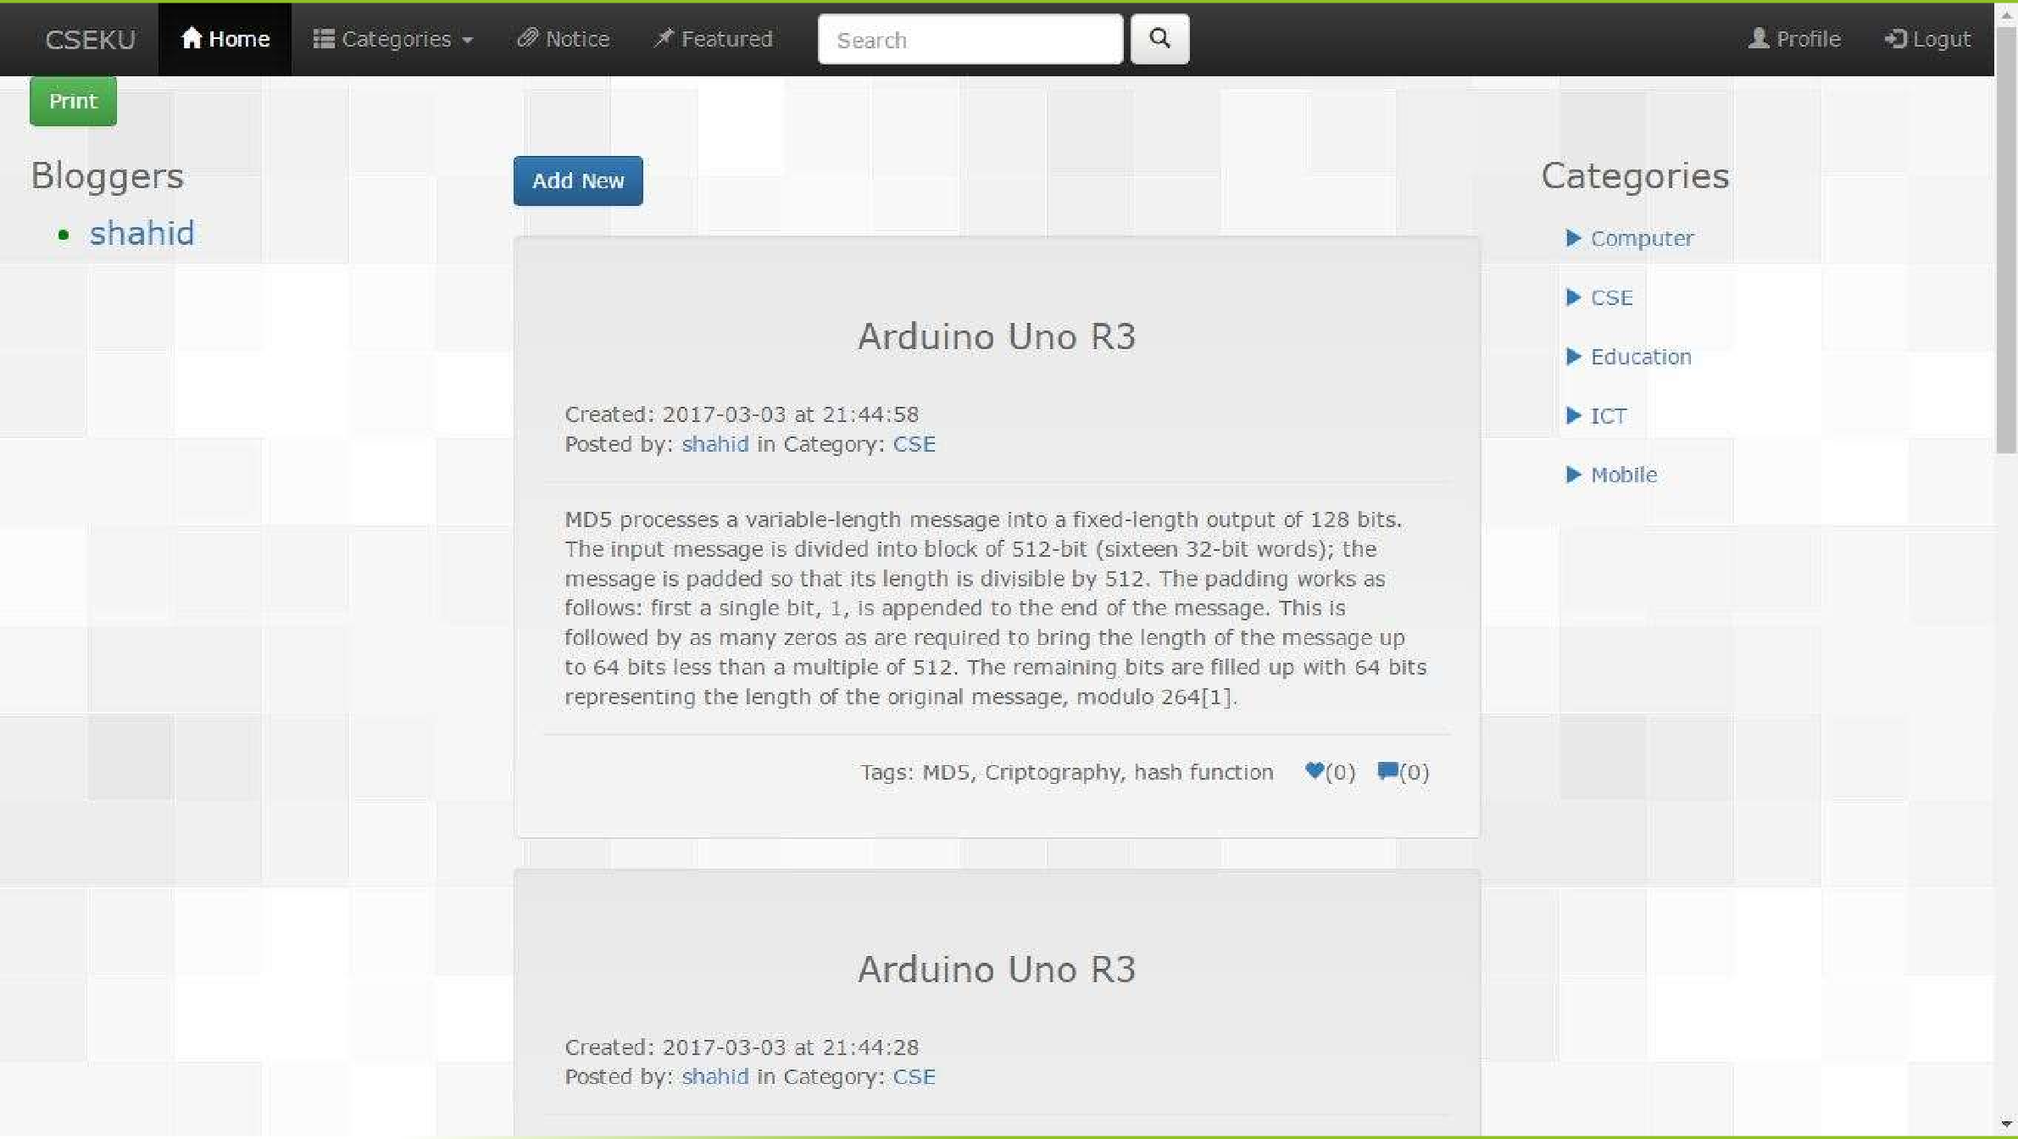

14

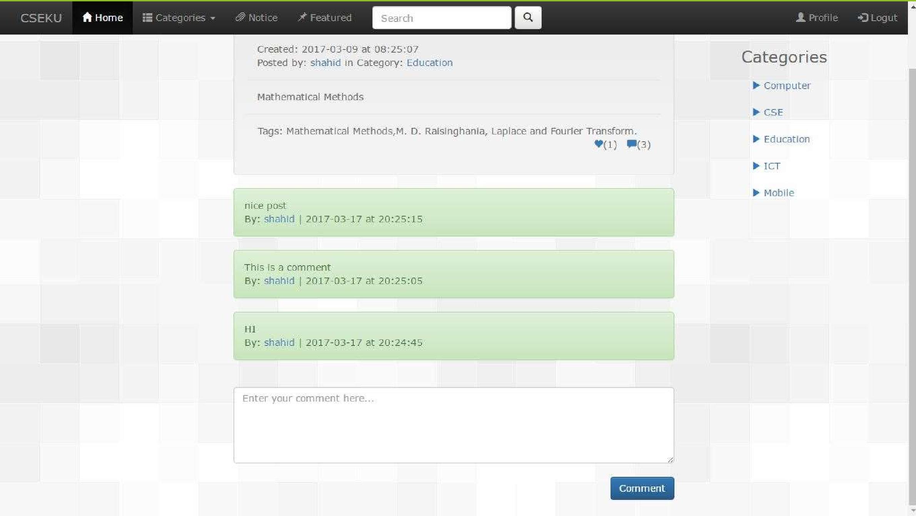

15

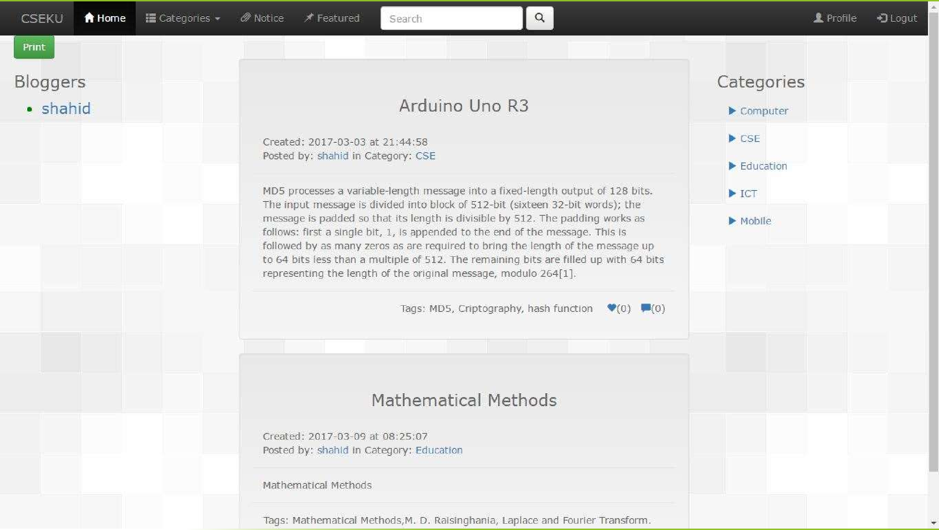

16

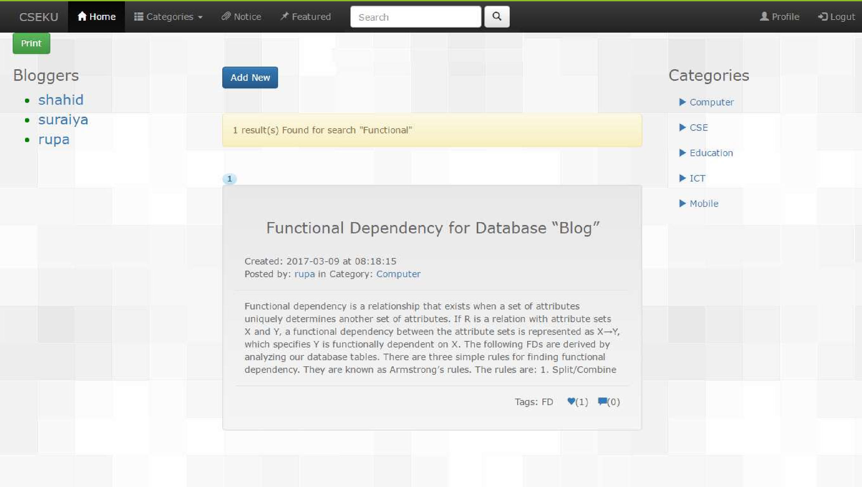

17

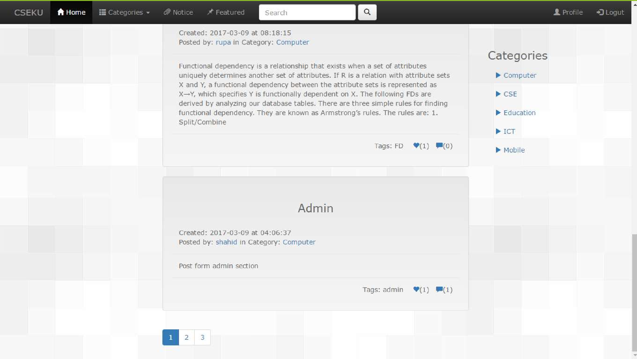

18

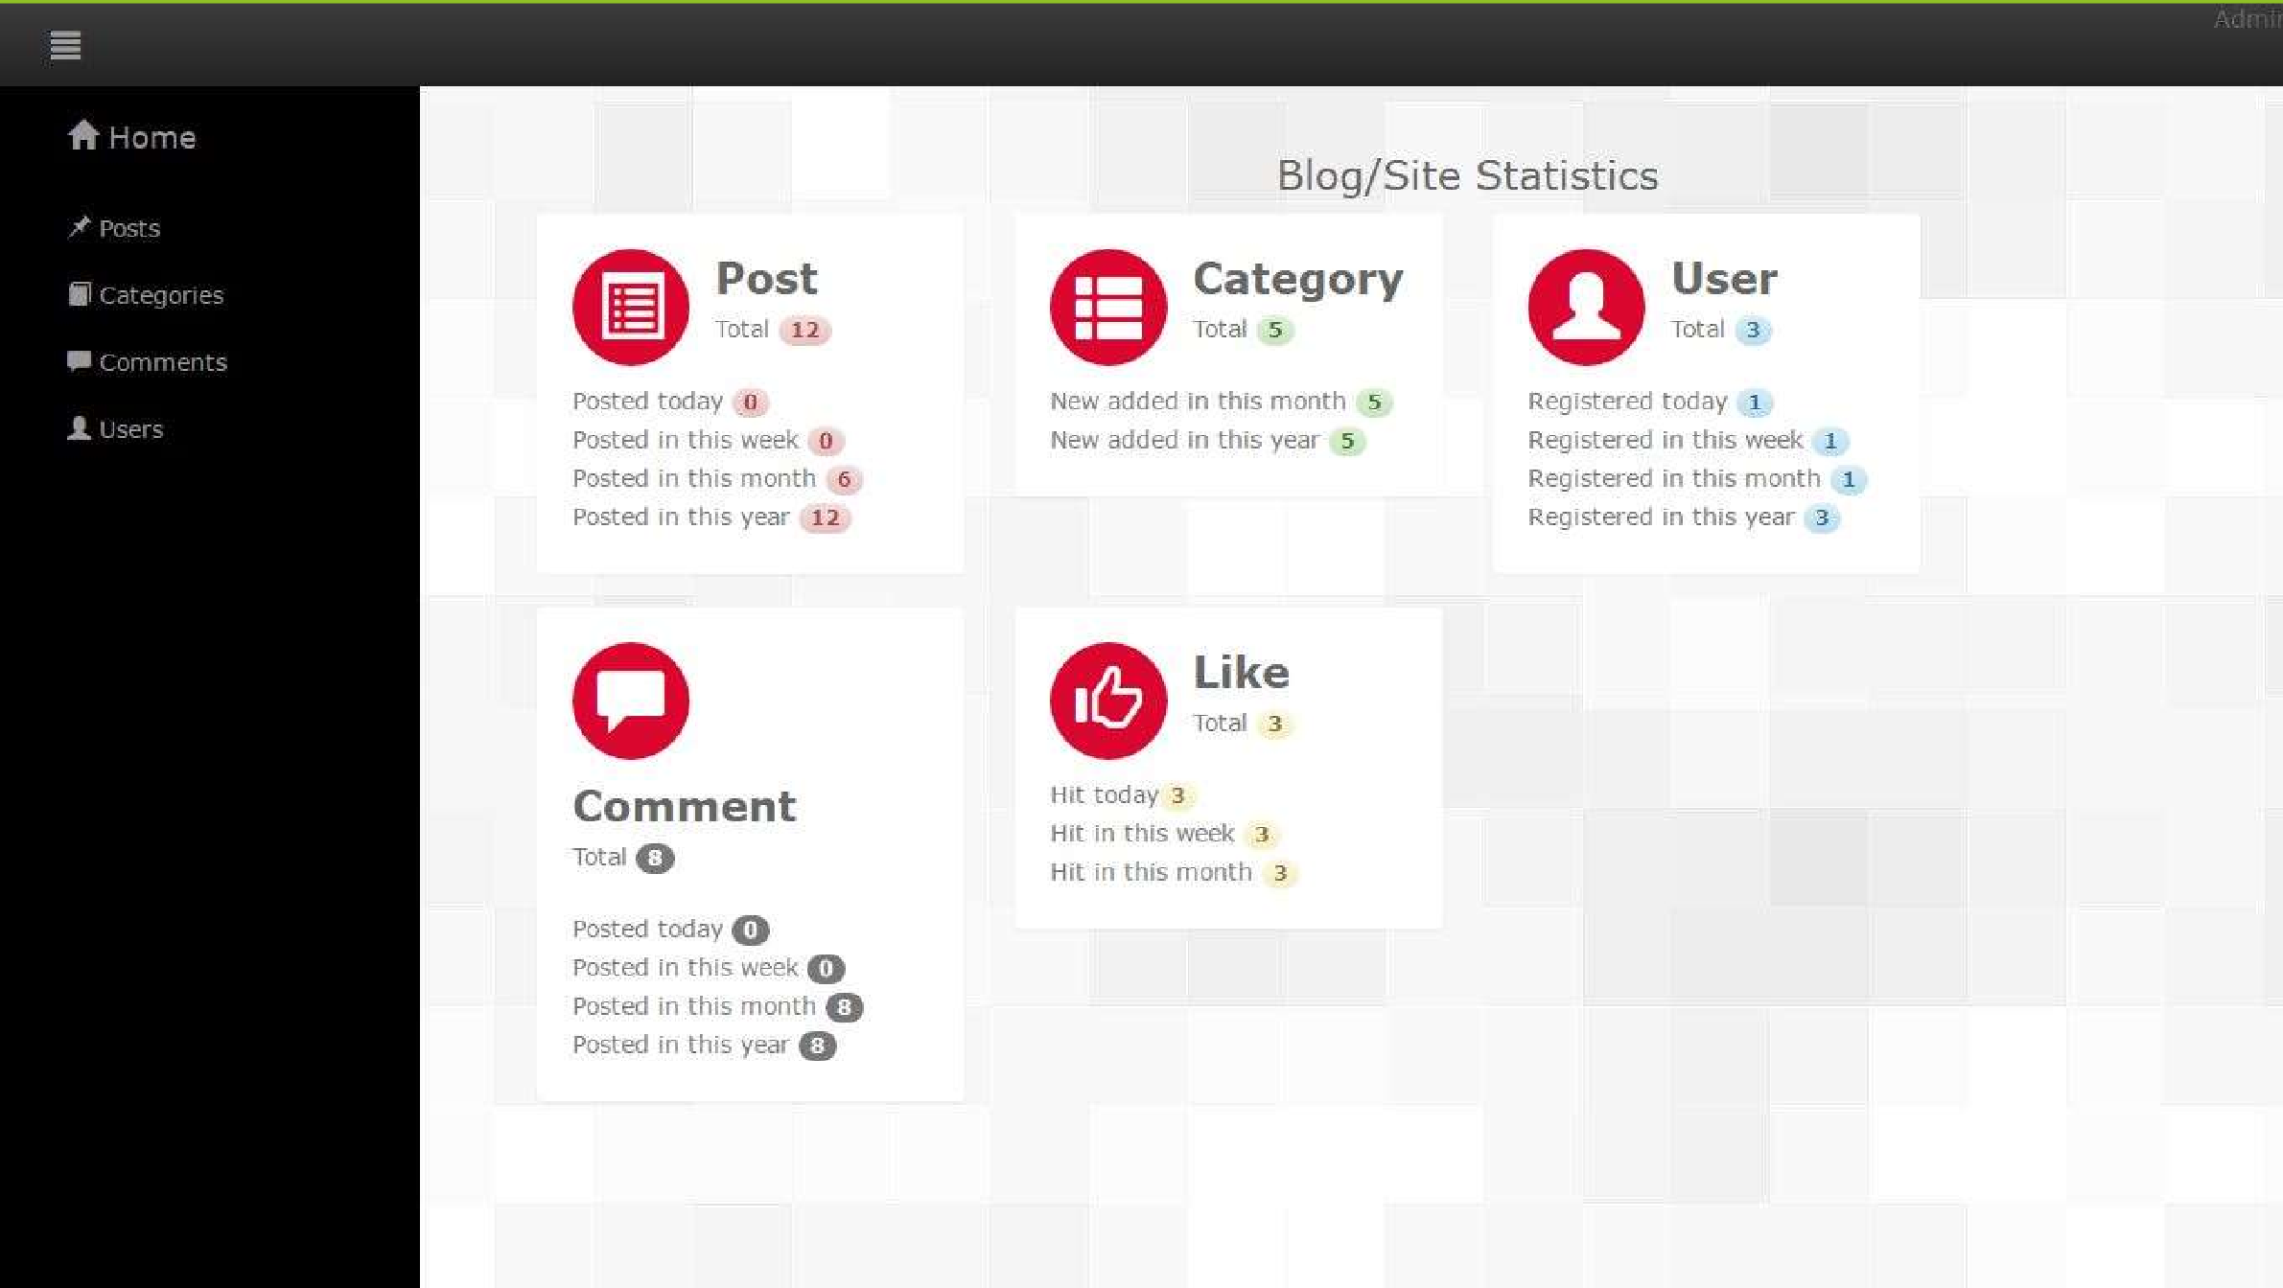

19

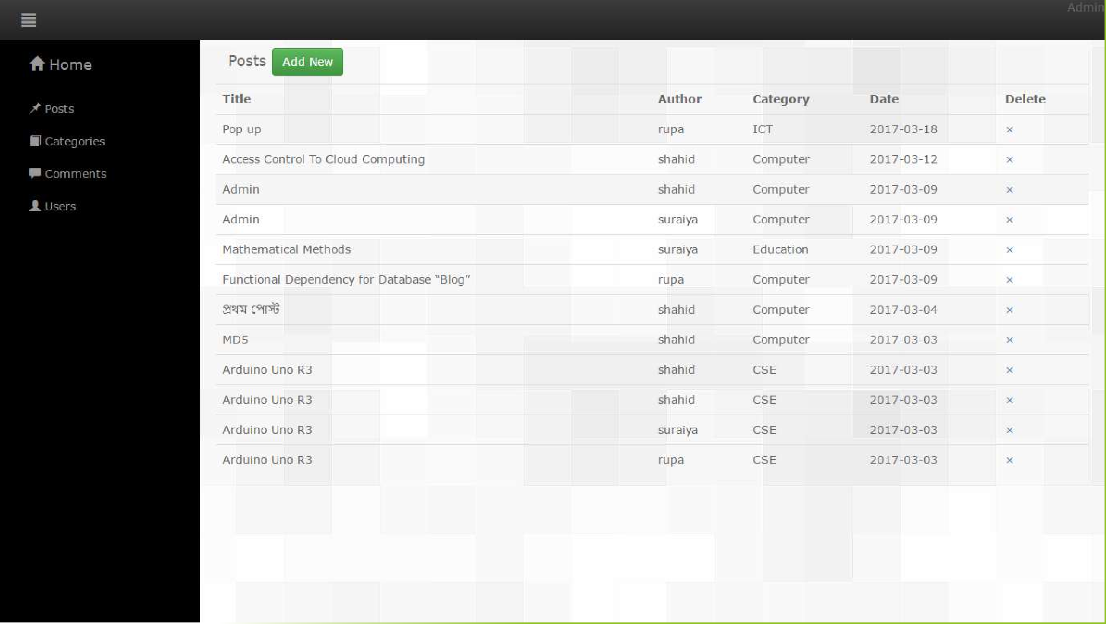

20

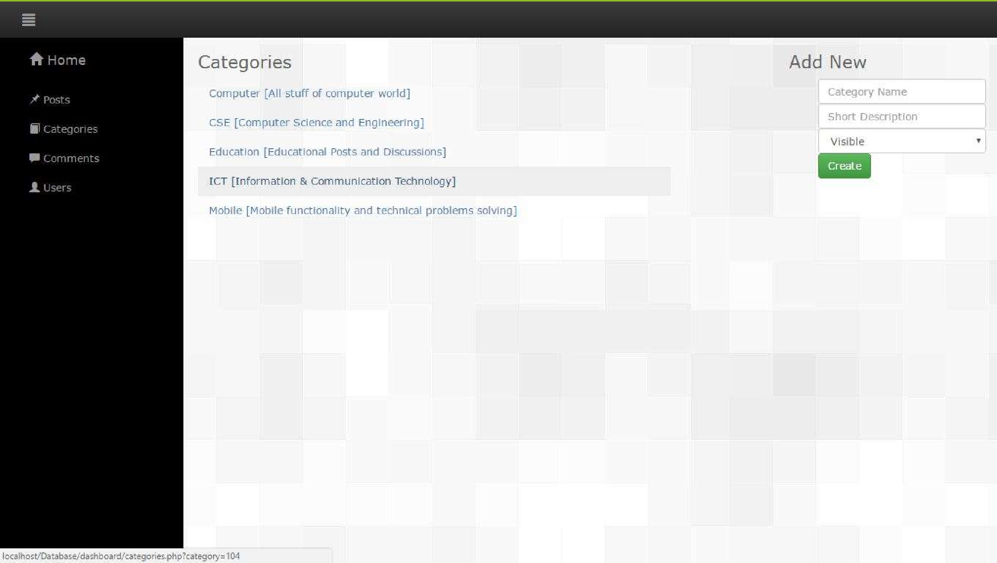

21

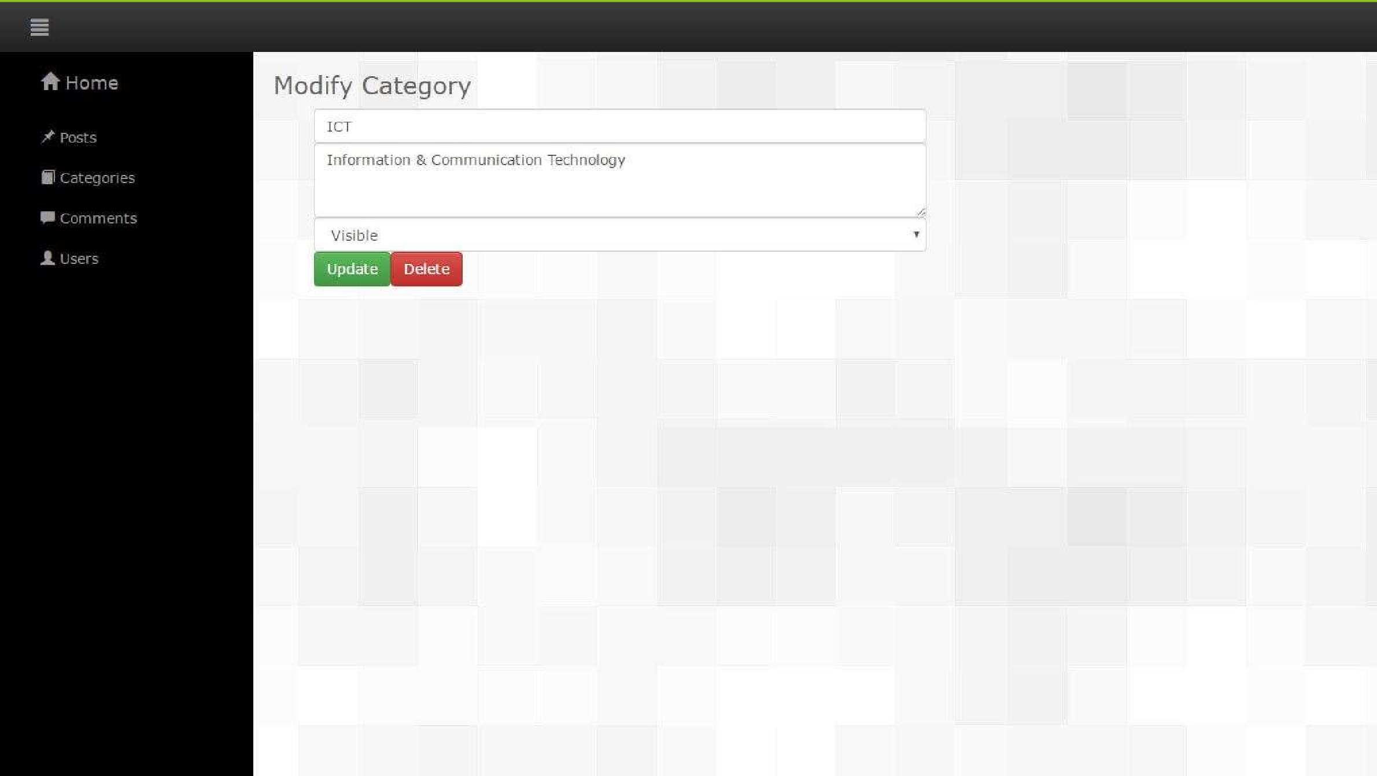

22

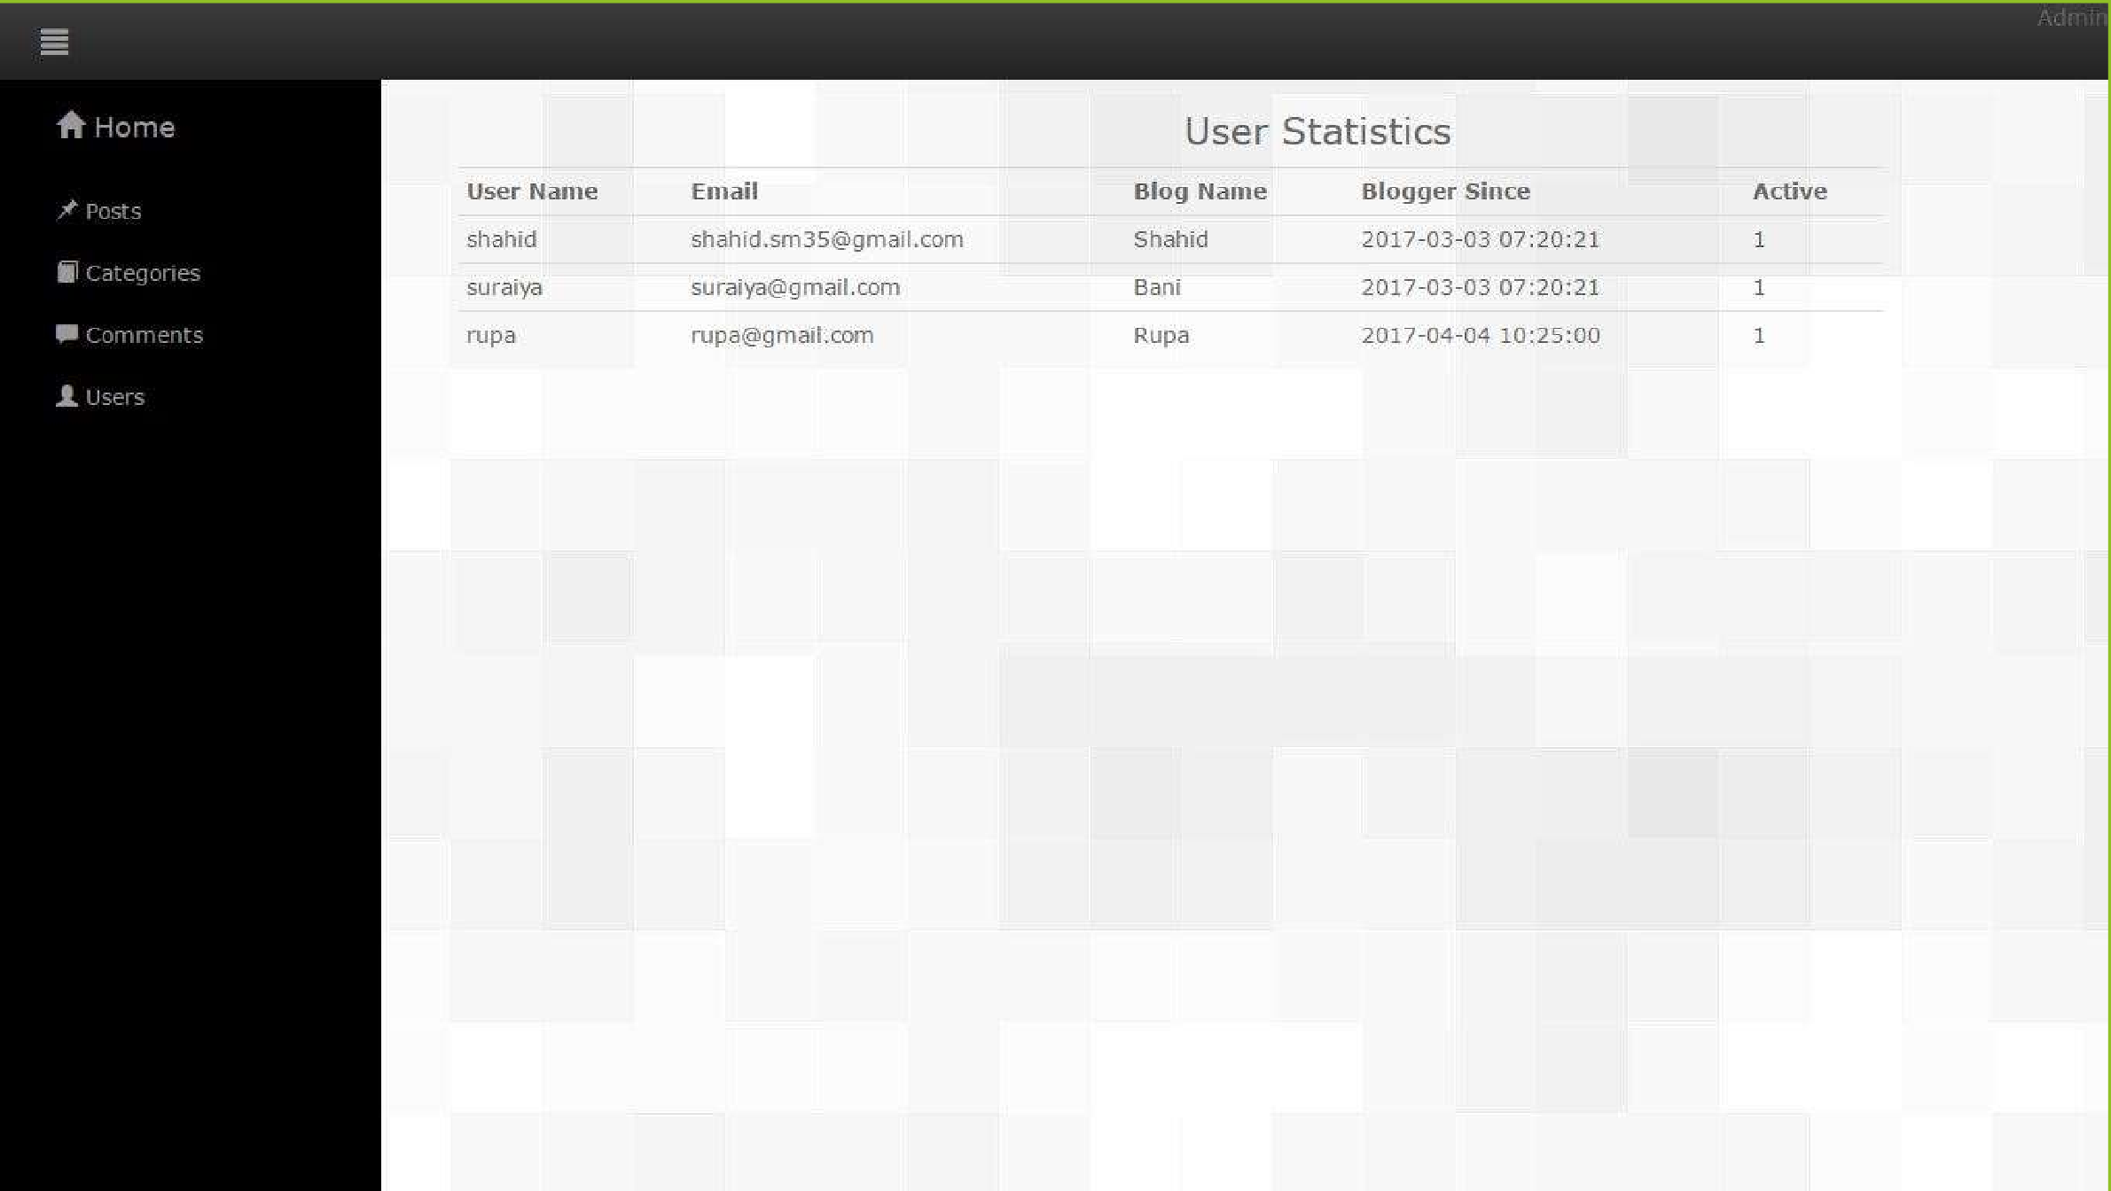

23





Conclusion

* Mail confirmation function implementation was not possible due to localhost server but we tested it.
* It wasn’t our plan but we worked on adding profile picture and image

on posts.